**Anton Slizh’s Solution Concept**

**DWH for “Kvas Boosted” Kvas Drinks Retailer Company**

**Overview**

Our company “Kvas Boosted” is specialized on retail of kvas drinks. For more than 5 years our company has been engaged in sales and occupies a leading position in the market. The main geographic region of sales activity is the CIS due to our specific and narrow scope of product range. But, regardless of mentioned limitations we are growing really fast and regularly opening new stores.

The company has contracts with different suppliers from all over the world. The drinks product list is presented both classic kvas types and specific tastes, depending of producer brands. Our customers are ordinary buyers with different income status.

Last year the company’s growth has slowed down. We want to find out the solution how to accelerate the company’s growth. Also, we want to understand the correlation of sales with different factors such as time, location, product, customer. The final solution should help us improve our sales policy and promote the company growth.

**Benefits**

The provided DWH can help business users in different ways:

1. It can help to better planning your business growth. According to well structured and represented data users can make important business decisions more accurately, what minimize risks of failure.
2. The data represented in DWH has high quality and structure. The data is strong standardized and don’t require special skills and knowledges to be accessed by ordinary business users.
3. The variety of gathered and processed data increase the range of business decisions users can make. It helps you to better understand all spheres and details of your business in real time. DWH solutions provide you the ability to prepare high quality reports, which covers all your business needs. Involving DWH system into your business significantly increase the understanding of processes which correlated with company growth and sales policy.

.

**Business requirements**

1. Calculating of sales statistics on time, product, location and customers factors.
2. Preparing well organized and documented reports, including diagrams and charts, according to business needs.
3. We want to better understand our customers to expand new markets in different locations.

**Technical Requirements**

1. The ease of use and access to the system.
2. The system should work at high availability mode.
3. The reports should be prepared on a daily basis.
4. Good integration with different external systems (banking, delivery etc.)
5. High performance and speed of calculating data.

**Solution Sketch**

**Logical Star Schema:**

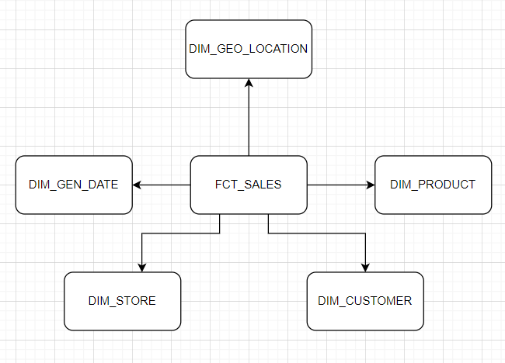

**Physical Star Schema:**

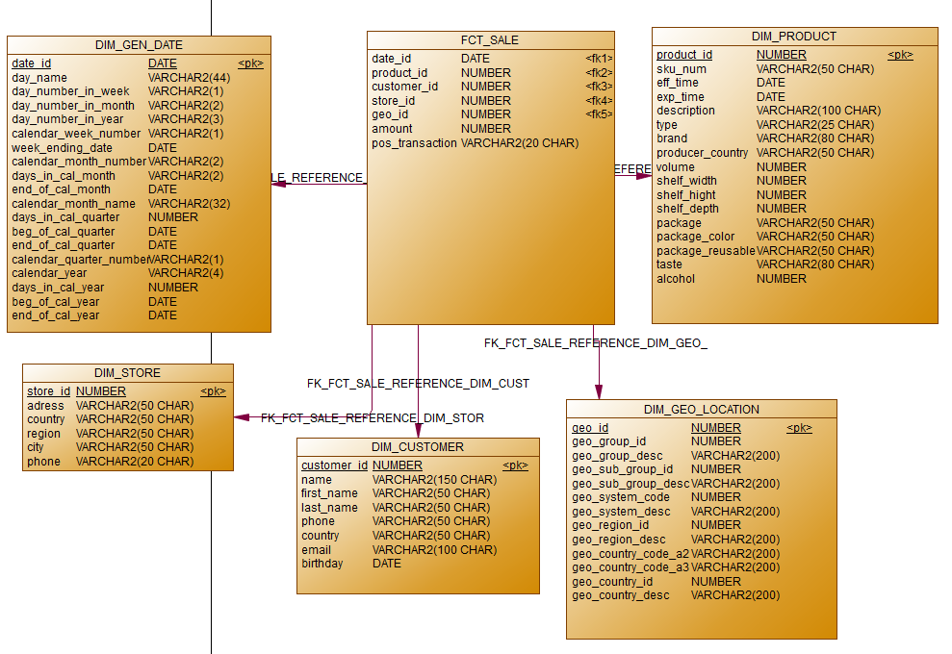

**Dimensions:**

|  |  |  |  |  |
| --- | --- | --- | --- | --- |
| Name | Type | Size | DW – Merged Dimensions | Descriptions |
| DIM_GEN_DATE | SCD1 | BIG | DW.T_DAYS, DW.T_WEEKS, DW.T_MONTHS, DW.T_QUARTERS,  DW.T_YEARS | TBD – Example row |
| DIM_PRODUCT | SCD2 | SMALL | product_id  sku_num  eff_time  exp_time  description  type  brand  producer_country  volume  shelf_width  shelf_hight  shelf_depth  package  package_color  package_reusable  tase  alcohol | This dimension contains the information about kvas drinks products, which are presented in company stores. The dimension has SCD2 type, which allow us to keep history of product changes (for example producer changed the volume or color of package). The *eff_time* and *exp_time* attributes represent the time period when record was active. The *sku_num* attribute represented as natural key for dimension. |
| DIM_CUSTOMER | SCD1 | SMALL | customer_id  name  first_name  last_name  phone  country  email  birthday | This dimension contains information about ordinary customers. |
| DIM_STORE | SCD1 | SMALL | store_id  address  country  region  city  phone | This dimension contains information about company stores, which are located in different countries and cities. |
| DIM_GEO_LOCATION | SCD1 | SMALL | Geo_id  Geo_group_id  Geo_group_desc  Geo_sub_group_id  Geo_dub_group_desc  Geo_system_code  Geo_system_desc  Geo_region_id  Geo_region_desc  Geo_country_code_a2  Geo_country_code_a3  Geo_country_id  Geo_country_desc | This dimension contains information about countries, regions, groups. This information describes the location where company stores are located. |

**Dimension Hierarchies:**

**DIM_GEN_DATE:**

**Hierarchy DAY-WEEK-MONTH-YEAR**

|  |  |  |  |
| --- | --- | --- | --- |
| Name | LEVEL_CODE | LEVEL_DESC | LEVEL_NATURAL_KEY |
| DAYs | DAY | Store all day at the calendar week | DAY_ID |
| WEEKs | WEEK | Store all weeks at the calendar month | WEEK_ID |
| MONTHs | MONTH | Store all months at the calendar year | MONTH_ID |
| YEARs | YEAR | Store all years | YEAR_ID |

**Hierarchy DAY-QUARTER-YEAR**

|  |  |  |  |
| --- | --- | --- | --- |
| Name | LEVEL_CODE | LEVEL_DESC | LEVEL_NATURAL_KEY |
| DAYs | DAY | Store all day at the calendar week | DAY_ID |
| QUARTERs | QUARTER | Store all quarters at the calendar year | QUARTER_ID |
| YEARs | YEAR | Store all years | YEAR_ID |

**DIM_GEO_LOCATION:**

**Hierarchy COUNTRY-REGION-PART-SYSTEM**

|  |  |  |  |
| --- | --- | --- | --- |
| Name | LEVEL_CODE | LEVEL_DESC | LEVEL_NATURAL_KEY |
| COUNTRIEs | COUNTRY | Store all counties in the geographic region | COUNTRY_ID |
| REGIONs | REGION | Store all regions in the part of the world | REGION_ID |
| PARTs | PART | Store all parts int the world | PART_ID |
| SYSTEMs | SYSTEM | Store system world | GEO_SYSTEM_ID |

**DIM_PRODUCT:**

**Hierarchy PRODUCT-BRAND-TYPE**

|  |  |  |  |
| --- | --- | --- | --- |
| Name | LEVEL_CODE | LEVEL_DESC | LEVEL_NATURAL_KEY |
| PRODUCTs | PRODUCT | Store all products of definite brand | PRODUCT_ID |
| BRANDs | BRAND | Store all brands of definite type | BRAND_ID |
| TYPEs | TYPE | Store all types | TYPE_ID |

**DIM_STORE:**

**Hierarchy STORE-CITY-REGION-COUNTRY**

|  |  |  |  |
| --- | --- | --- | --- |
| Name | LEVEL_CODE | LEVEL_DESC | LEVEL_NATURAL_KEY |
| STOREs | STORE | Store all stores of city | STORE_ID |
| CITIes | CITY | Store all cities of country region | CITY_ID |
| REGIONs | REGION | Store all regions of country | REGION_ID |
| COUNTRIes | COUNTRY | Store all countries where stores are located | COUNTRY_ID |

**Facts:**

FCT_SALES

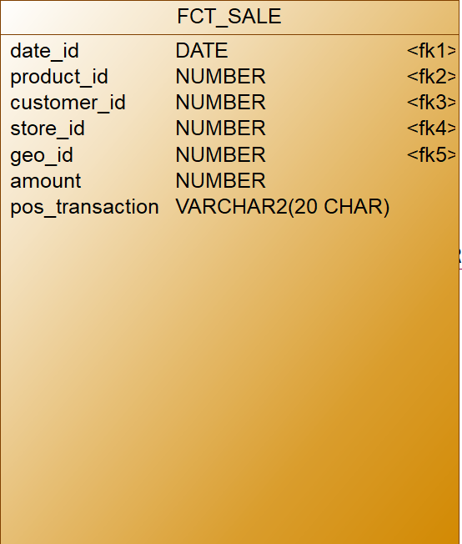

FCT_SALES represent individual sale transaction. Table contains 2 fact attributes. The *amount* attribute represents the number of individual product units. The *pos_transaction* represents the code of transaction that provide us to accumulate all products in definite basket.

Facts aggregations for the FCT_SALES table:

|  |  |  |  |  |
| --- | --- | --- | --- | --- |
| Name | Code | Table Name | Additive | Descriptions |
| Total number of products sold | amount | FCT_SALES | + | Calculates the number of sales according to range of time, product etc. |
| The code of transaction | pos_transaction | FCT_SALES | - | Accumulate all products from one basket (with same *pos_transaction)* |